### **Return the Attached**

### **Membership Form To:**

Washington County

OSU Extension Center

209 E 12th Street

P.O. Box 10

Dewey, OK 74029

918-534-2216

*A representative of our organization will contact you.*

### **Groups Meet Once a Month**

Acorns OHCE – 1st Mon. 7:00 pm

Cherokee OHCE – 2nd Thurs. 1:00 pm

Eager to grow OHCE – 2nd Thurs. 1:30 pm

Home Builders OHCE – 2nd Wed. 11 am

Home Ex OHCE – 2nd Mon. 1:15 pm

Penn’ N Tux OHCE – 3rd Mon. 9:00 am

Show & Tell OHCE – 2nd Mon. 9:15 am

Sunset OHCE – 4th Mon. 7:30 pm

Rising Star OHCE – 2nd Thurs 7:00 pm

Oak College OHCE – 1st Mon. 9:00 am

Knot Sew Perfect – 2nd Wed. 11 am.

### **Dues of the Organization**

Washington County OHCE $2.50

OHCE State Membership $12.50

Total Annual Dues $15.00

### **Mission of OHCE**

To encourage individuals to live up to his/her potential and to encourage participation in all phases of family and community life.

**County Website:**

[Oklahoma State University Extension](http://oces.okstate.edu/washington)

**State Website:**

## [Oklahoma Home and Community Education](https://extension.okstate.edu/programs/oklahoma-home-and-community-education/)**Oklahoma Home and**

## **Community Education**

## **Washington County**

Our county program, as a part of Oklahoma Home and Community Education (OHCE), is a program of continuing education in all aspects of home and community life. The organization’s ultimate aim is to educate its members to be well informed and able to guide change in their homes and communities.

Through a partnership with the Oklahoma Cooperative Extension Service, OHCE presents research-based information to its members and the public, through monthly leader lessons and district and state meetings. Leadership development and community service projects provide OHCE members with further opportunities to apply this research-based information to practical use for their homes and communities.

Membership in OHCE and services provided by Oklahoma Cooperative Extension Service (OCES) are open to all persons regardless of age, race, color, religion, sex, disability, gender, national origin, sexual orientation, or status as a veteran.

# **Oklahoma**

# **Home and**

# **Community**

# **Education**

# Washington

# County

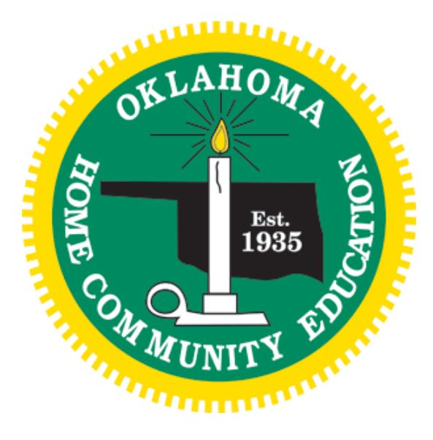

## Working Together

## To Build

## Better Communities

## Through

## Leadership & Service

## **Contact Request Form**

Name

Address

City       Zip

Phone

E-mail

Washington County has several groups in your area.

### **Attend**

Monthly meetings for educational programs and to make new friends that share your interests.

### **Participate**

In projects of your choice that benefit you, your family, and your community.

### **Join OHCE**

To join OHCE through the Washington County OSU Extension Center

**Call 918-534-2216**

To learn more information, visit our website

at [Oklahoma Home and Community Education](https://extension.okstate.edu/programs/oklahoma-home-and-community-education/)**Education – Families**

*Are What We Are All About*

**Oklahoma Home and Community Education**

Washington County

## **Educational Programs**

* Environmental Issues
* Literacy
* Character Education for Children
* Prescription Drugs
* Money Management
* Nutrition
* Healthy Aging
* Community Services

## **Educational Events**

* Family Workshops
* County Fair
* Educational Tours
* Workshops & Seminars
* Arts & Crafts
* Club Events
* Quarterly County Meetings
* State & District Events

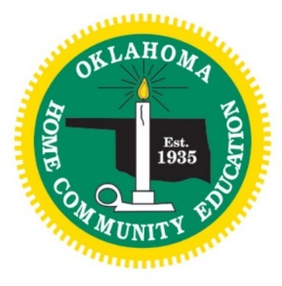

***Program Areas…An OHCE Focus***

**Healthy Living** – Provide current information to assure maintenance of healthy environment and lifestyle.

**Leadership Development** – Educational opportunities for members to excel in the areas of volunteer leadership.

**Resource Management** – increased awareness in areas of financial responsibility, resource conservation.

**Cultural Enrichment** – Enrich our lives by studying our culture and the cultures of others.

**Family Enhancement** – To improve the life of families in our communities.

Our organization has a proud Oklahoma heritage. Members live in all 77 counties. Many local meeting groups were established as early as 1916. Organized statewide in 1935, OHCE is incorporated, non-profit and self-sustaining.

OHCE holds affiliate memberships with Country Women’s Council USA, Associated Country Women of the World, OCES-FCS Ambassadors and Oklahoma Partnership for Public Deliberation.