Oklahoma Home & Community Education 2023 Handbook

Message from State President, Kathy Fentress
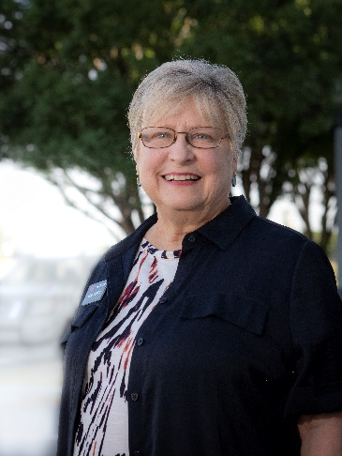

G.R.E.A.T. – Get Really Excited About Today

When thinking about what my theme would be for my first year as president, I considered several possibilities, but G.R.E.A.T. – Get Really Excited About Today is the one that truly spoke to me. Each day is a day full of possibilities and opportunities. Today is inherently exciting because today we are given a chance to become better people than we were yesterday. Excitement focuses our intent on positive improvement. It leads us in positive directions. Of course, a positive direction doesn’t mean that obstacles just disappear. But lecturer at Stanford’s Graduate School of Education, Piya Sorcar says, “Focus on excitement, and it will lead you through the obstacles.” Excitement energizes us to work creatively to deal with obstacles instead of getting bogged down. Excitement keeps us moving forward! Excitement improves our attitude and lifts our spirits. Choose excitement and imagine the difference being excited about today could make in everything we do! Excitement empowers us to transform today.

We need excitement today both in our own lives and in our OHCE groups. All the positive aspects excitement brings to our personal lives also applies to our leadership and membership in OHCE. Just think what a difference excited leaders and members would make to groups across the state and OHCE as a whole! Choose to get excited. Make today amazing. Let’s make it G.R.E.A.T. – Get Really Excited About Today!

Biography

Born an Oklahoma girl, Kathy Fentress grew up in Lawton in Comanche County. Transplanted in Texas for more than 30 years, she returned to Oklahoma to Broken Bow where she and husband, Bob, retired. Kathy and Bob have been married for 47 years and have a daughter and a son, both married to great spouses. Her very precious and precocious grandson keeps her on her toes and brings lots of joy to her and her family.
Volunteering has made up a huge part of Kathy’s life. While living in Texas, she volunteered at hospitals, schools, and in a number of civic organizations. When she moved to Broken Bow, she sought opportunities to volunteer and found OHCE. In 2011 Kathy joined OHCE and has served as both group and county President. Her first office on the state board was Southeast District Representative followed by Leadership Chair, Vice President for Programs, and Awards and Reports Chair. Membership in OHCE and serving on the state board has enriched her life and provided many opportunities for learning, leadership, and personal growth. She says, “OHCE is by far the best place to spend my volunteer time.” She is an FCS Master Volunteer and loves the opportunities OHCE provides her to give back and work in her community especially with young people.
Kathy feels incredibly honored to serve as OHCE State President. She loves the sense of community and friendship she finds in OHCE. She believes OHCE is an exciting, dynamic organization with a strong state board and strong members. Kathy says, “The people in OHCE and those associated with OHCE are some of the most caring and giving people I have ever been privileged to know.” She believes that working together will keep OHCE moving forward and doing what it does best – educate members and others, improve family life, and make a difference in communities across the state.

Message from the OHCE State Advisor, Dr. Gina Peek
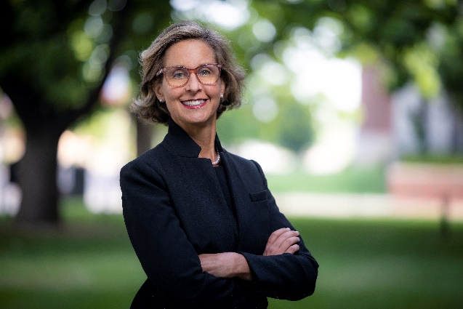
Dear OHCE,
I have taken a moment to look at the OHCE website and reacquaint myself with the 2023 state goals. From cultural enrichment to leadership development, family issue to health living, OHCE is making things happen at the local and state level. Thank you for your commitment to making an impact in Oklahoma. Your good work makes a difference! As always, I look forward to our district and summer meetings and wish you a productive and successful year.
All the best,
GP

Biography

Gina Peek is a Wisconsin native and first-generation college graduate. Gina attended the University of Georgia for both her master’s (May 2004) and Ph.D. (December 2009) degrees. Upon graduation, she joined the Department of Design, Housing and Merchandising in the College of Human Sciences as the Oklahoma Cooperative Extension Service (OCES) state housing and consumer specialist. Gina became department graduate coordinator in January 2016 and Associate Department Head in July 2018. She was appointed Interim Associate Dean for Extension, Engagement and Continuing Education on June 1, 2020, and was made permanent July 1, 2022. The College of Education and Human Sciences tagline “People. Passion. Purpose.” sums Gina’s philosophy. The land-grant university has the honor of serving by providing unbiased research-based education to solve human problems and enhance human lives. Gina feels it her duty to bring this philosophy to life. When not at the office, Gina enjoys spending time with two teenage daughters, Jenkins (20) and Hampton (16). Favorite recreational activities include biking, running, and swimming. And growing roses!

Past OHCE State Presidents

1935-36 Mrs. Joe Seikel
1936-38 Mrs. Robert Broughton
1938-40 Mrs. Emma Orrell
1940-42 Mrs. Elbert Piper
1942-44 Mrs. R.S. Duncan
1944-46 Mrs. Leon Lorg
1946-48 Mrs. Paul Schmuck
1948-50 Mrs. J. W. Storer
1950-52 Mrs. O. G. Rushing
1952-54 Mrs. David Foster
1954-56 Mrs. B. Trotter
1956-58 Mrs. Marie Thomas
1958-60 Mrs. Leola Smith
1960-62 Mrs. Raymond Coffelt
1962-64 Mrs. Dean Carter
1964-66 Mrs. A.A. Holder
1966-68 Mrs. Horace Wood
1968-70 Mrs. Paul Kunneman
1970-72 Mrs. Don Weinkauf
1972-74 Mrs. Bennie Tice
1974-76 Mrs. Kenneth Powell
1976-78 Mrs. Frank Sickles
1978-80 Mrs. Sheila Ely
1980-82 Mrs. June Anderson
1982-84 Mrs. Doshia Jackson
1984-86 Mrs. Donna Schwerdtfeger
1986-88 Mrs. Norma Shipman
1988-90 Mrs. Bette Boudinot
1990-92 Mrs. Linda Burcham
1992-94 Mrs. Jean Page
1994-96 Mrs. Celia Dupus
1996-99 Mrs. Sue Rendel
1999-00 Mrs. Barbara Cox
2000-02 Mrs. Dianne Cathey
2002-04 Mrs. Terrie DeShazo
2004-06 Mrs. Debra Stevenson
2006-08 Mrs. Donna Jones
2008-10 Mrs. Javonna Earsom
2010-12 Mrs. Sue Gilliam
2012-14 Mrs. Pam Vaughn
2014-16 Mrs. Shirley Burns
2016-18 Mrs. Debbie Mote
2018-20 Mrs. Leslye Owen
2020-2022 Sandy Pogue

2023 Projected Budget
Oklahoma Home Education, Inc. Income and Expense Budget
January 1 thru December 31, 2023
Income
2021 Dues (based on 3000 members) |  | 37,500.00
Interest Income |  | 1,275.00
Promotional Sales |  | 4,500.00
Other Income |  | 227.00
Income for Say Yes to FCS Scholarship |  | 1,000.00
Total Income |  | 44,502.00
Expenses
Awards & Scholarships
- Income for Say Yes to FCS Scholarship | 1,000.00
- Member, Rookie, Young, Heart Awards | 500.00
- Student Scholarship | 1,500.00
Total Awards and Scholarships |  | 3,000.00
Awards-State Committees
- Cultural Enrichment | 100.00
- Family Issues | 100.00
- Photography | 50.00
- Healthy Living | 100.00
- Leadership Development | 100.00
- Life Essay | 50.00
- Membership | 200.00
- Military Support | 100.00
- Membership Recruitment | 100.00
- Resource Management | 100.00
- Madelyn’s Special Award | 100.00
- OHCE Week | 100.00
- State Project | 100.00
Total Awards – State Committees |  | 1,300.00
Dues, Ins. & Fees
Bank Charges | 50.00
Bonding Fee | 350.00
CWC – Delegates | 1,500.00
Dues – ACWW | 175.00
Dues – CWC | 90.00
Insurance – Liability | 4,500.00
Total Dues, Ins. & Fees |  | 6,665.00
Officer and Chairman Expenses
- Awards | 1000.00
- By-Laws | 200.00
- Cultural Enrichment | 425.00
- Editor | 225.00
- Family Issues | 200.00
- Healthy Living | 200.00
- Historian | 200.00
- Leadership Development | 200.00
- Membership | 400.00
- Nominating | 200.00
- President | 2,000.00
- Chaplain | 250.00
- Parliamentarian | 400.00
- Promotional Sales | 1,000.00
- Resource Management | 200.00
- Secretary | 850.00
- State Project | 250.00
- Treasurer | 850.00
- Vice President for Program | 850.00
Total Officer and Chair Expenses |  | 9,900.00
OHCE Meetings -
- State OHCE Meeting | 7,000.00
- Fall Planning Meeting | 5000.00
- Spring Evaluation Meeting | 5000.00
Total OHCE Meeting |  | 17,000.00
Other Expenses
Oklahoma Outreach | 3,500.00
Promotional Sales Purchases | 2,500.00
Sales Tax expense | 312.00
Sales Tax Permit | 25.00
Tax Preparation | 300.00
Total Other Expenses |  | 6,637.00
Total |  | 44,502.00

Organization of OHCE
The object of the Oklahoma Home and Community Education organization is to develop leadership, to promote and to extend the best interest of the family, home, and community through a County OHCE organization.
The county OHCE organization is made up of the membership of each local group. It is governed by the elected officers of the county organization and the president and secretary of each local group.
The local OHCE group is organized at the community or local level for the purpose of studying Family and Consumer Sciences and putting into practice research-based methods for improving family life. The local OHCE groups offer women and men an opportunity for personal and community involvement. Each OHCE group elects its own officers and selects its own committee chairs. It also has its own representation in the county OHCE organization.

OHCE Program of Work & Objectives

OHCE Program of Work
The Oklahoma Home and Community Education organization recognized that an essential feature of the organization members’ work is that all programs are planned by people in each county, and that careful analysis of their home and community needs its basic to the achievement of successful programs. It is not the intent of OHCE to unduly influence either county or local group members’ programs, rather it is to call to the attention of program planning committees, some areas of concern that they may wish to consider when developing their organization member program. It is suggested counties and local groups choose whichever part(s) of the total program is most suited for their particular state and county.

OHCE Objectives
- To develop leadership and family strengths
- To identify, develop and coordinate special projects in cooperation with other private organizations.
- To promote peace, friendship and understanding.
- To develop financial stability and security.
- To encourage community involvement.
- To promote a healthier and safer American.
- To conserve energy and natural resources.

OHCE 2023 Calendar of Events
January 1 OHCE State fiscal year begins
January 1 OHCE Program Area Goals begin
January 25 Deadline for February Outreach
February 1 Annual Award Nominee completed forms to State Awards Chair
February 1 County and Local Reports due to State Awards Chair
February 1 Nomination forms for state offices due to State Nominating Committee Chair
February 15 State Nominating Committee evaluates qualification forms for state board positions
March 7 SE District Meeting: Moore, OK
March 21 West District, South Region: Quartz Mountain State Park Lodge
March 25 West District, North Region: Enid, OK
March 28 NE District Meeting: Tulsa Tech, Owasso
April 6 OEAFCS Annual Awards Banquet, (Embassy Suites, 1815 South Meridian, OKC) – Cultural Enrichment chair presents Norman Brumbaugh Awards
April 13 OCES-FCS Ambassadors Annual Meeting & Luncheon, OK County Extension Center
April 13 OHCE State Board meeting, Oklahoma City
April 14 Awards Book Evaluation meeting, Oklahoma City
April 24 Deadline for May Outreach
April 29 ACWW Day – Women Walk the World
May 7-13 OHCE Week (first full week in May, Sunday through Saturday)
May 17-25 ACWW Triennial World Conference, in Kuala Lumpur, Malaysia
May 25 Deadline for OHCE Week Reports to Membership Chair

June 1 Deadline for 50, 60, 70-year members to Membership Chair
July 1 Cut off for receiving 2023 state dues
July 9-11 Annual OHCE State Meeting
July 11 New OHCE Board Members and appointees begin duties
July 31 OHCE State Board Meeting: Stillwater, OK

August 1 OHCE State Board Goal Planning Session: Stillwater, OK
August 24 Deadline for September Outreach
September 1 County Presidents review state officer and committee qualification forms, encourage members to serve on State Board
September 15 2024 State Goals published and sent to counties
September 15 Deadline to send all financial claims for reimbursement to State Treasurer
October 1 County Treasurer collects 2024 dues, $12.50 per member
October 15 International Day of Rural Women
October 16 World Hunger Day
November 1 Deadline for County Treasurers to collect 2024 dues to be sent to State Treasurer with updated Membership Roster
November 1 Donations due to State Treasurer for Pennies for Friendship, Norma Brumbaugh Scholarship, and CWC USA
November 1 List of County Officer and Committee Chairs due to state office (Dr. Gina Peek)
December 1 State Treasurer prepares books for tax preparation
December 31 End of State OHCE Fiscal Year
HAPPY NEW YEAR!!

Quick Links

Policy and State Board
OHCE Policy Book
OHCE State Board
OHCE County Officers

Oklahoma Cooperative Extension Service
District Map
Family and Consumer Sciences State Specialists
OSU Extension County Offices
  - Find an Educator
  - Educator Spotlight

Grants
Ambassador/Blackwell and Fitch Grants
Leadership Development and Community Engagement (LDCE) grants

State Goals 2023
Cultural Enrichment
Family Issues
Resource Management State Goals
Healthy Living
Leadership Development State Goals
Membership State Goals

State Project
2023 State Project - Reducing Childhood Hunger

Member Awards
- Heart of OHCE Award Nomination form
- Rookie Member Award Nomination form
- Young Member Award Nomination form
- Member Award Nomination form
- Membership Recruitment Award Form

Report Book Awards
Rules for County Photography Contest and Life Stories
Criteria for Report Book Entries
Criteria for Judging OHCE Program of Work

