Oklahoma Home & Community Education 2024 Handbook

Message from State President, Kathy Fentress
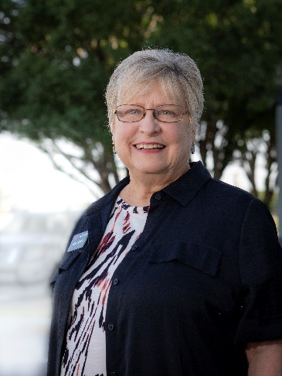

TEAM —Together Everyone Achieves More

Last year’s theme focused on being excited about each day, and what we do each day in our personal lives and in OHCE. OHCE members demonstrated the difference excitement made in the positive gains our organization achieved last year. Last year, attendance increased at District Meetings, project award report numbers increased, and OHCE membership increased significantly! Attitudes were more positive. In addition, the joy of being together and working together as OHCE members was evident. This year I hope we can keep this trend on the upward swing. That is why I chose TEAM — Together Everyone Achieves More to be the theme for my final year as OHCE State President.

Every team is made up of individuals working together to achieve a common goal. Isn’t that what all the groups in OHCE really are — teams of members working together to achieve a common outcome? Yes! A team is a talent pool. The talents and skills of all the team members merge together. Any gaps in individual skill sets are filled, and the team is able to better accomplish its goals. We are all familiar with the saying, “Many hands make light work.” When we work as a team, the burden of labor is lightened because it is divided among all the team members. This also means different parts of the project can be worked on at the same time bringing a project to fruition easier and faster. These are just a couple of ways working together as a teams can be beneficial to OHCE and each OHCE group. There are many more.

Let’s spend this year coming together as a team and exploring the many benefits. As members of OHCE we want to improve the lives of family and community. Working together, being a team makes this possible at the highest level because as a TEAM — Together Everyone Achieves More!

Biography
Born an Oklahoma girl, Kathy Fentress grew up in Lawton in Comanche County. Transplanted in Texas for more than 30 years, she returned to Oklahoma to Broken Bow where she and husband, Bob, retired. Kathy and Bob have been married for 48 years and have a daughter and a son, both married to great spouses. Her very precious and precocious grandson keeps her on her toes and brings lots of joy to her and her family.
Volunteering has made up a huge part of Kathy’s life. While living in Texas, she volunteered at hospitals, schools, and in a number of civic organizations. When she moved to Broken Bow, she sought opportunities to volunteer and found OHCE. In 2011 Kathy joined OHCE and has served as both group and county President. Her first office on the state board was Southeast District Representative followed by Leadership Chair, Vice President for Programs, and Awards and Reports Chair. Membership in OHCE and serving on the state board has enriched her life and provided many opportunities for learning, leadership, and personal growth. She says, “OHCE is by far the best place to spend my volunteer time.” She is an FCS Master Volunteer and loves the opportunities OHCE provides her to give back and work in her community especially with young people.
Kathy feels incredibly honored to serve as OHCE State President. She loves the sense of community and friendship she finds in OHCE. She believes OHCE is an exciting, dynamic organization with a strong state board and strong members. Kathy says, “The people in OHCE and those associated with OHCE are some of the most caring and giving people I have ever been privileged to know.” She believes that working together will keep OHCE moving forward and doing what it does best – educate members and others, improve family life, and make a difference in communities across the state.

Message from the OHCE State Advisor, Dr. Gina Peek
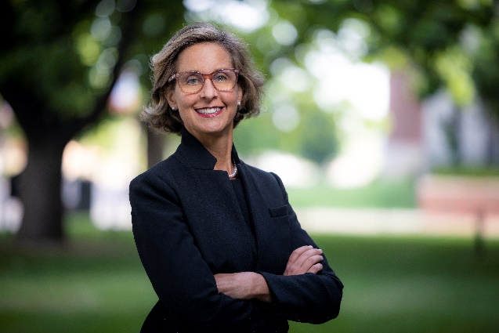
Dear OHCE,
I took a moment to review the OHCE website and familiarize myself with the 2024 state goals. Reading the documents sequentially provided a holistic view of OHCE, highlighting a variety of projects that will uplift OHCE members, communities, and the state. I am particularly delighted to observe the inclusion of the Master Volunteer program and anticipate substantial growth in this crucial area. As always, I look forward to our district and summer meetings and wish you a productive and successful year.

Biography

Gina Peek joined the Oklahoma Cooperative Extension Service (OCES) in 2010. Gina became the Interim Associate Dean for Extension, Engagement, and Continuing Education in June, 2020 and was named permanent in July, 2022. The College of Education and Human Sciences tagline “People. Passion. Purpose” sums Gina’s philosophy. When not at the office, Gina enjoys spending time with two daughters, Jenkins (21) and Hampton (17). Favorite recreational activities include being outside and growing roses!

Past OHCE State Presidents

1935-36 Mrs. Joe Seikel
1936-38 Mrs. Robert Broughton
1938-40 Mrs. Emma Orrell
1940-42 Mrs. Elbert Piper
1942-44 Mrs. R.S. Duncan
1944-46 Mrs. Leon Lorg
1946-48 Mrs. Paul Schmuck
1948-50 Mrs. J. W. Storer
1950-52 Mrs. O. G. Rushing
1952-54 Mrs. David Foster
1954-56 Mrs. B. Trotter
1956-58 Mrs. Marie Thomas
1958-60 Mrs. Leola Smith
1960-62 Mrs. Raymond Coffelt
1962-64 Mrs. Dean Carter
1964-66 Mrs. A.A. Holder
1966-68 Mrs. Horace Wood
1968-70 Mrs. Paul Kunneman
1970-72 Mrs. Don Weinkauf
1972-74 Mrs. Bennie Tice
1974-76 Mrs. Kenneth Powell
1976-78 Mrs. Frank Sickles
1978-80 Mrs. Sheila Ely
1980-82 Mrs. June Anderson
1982-84 Mrs. Doshia Jackson
1984-86 Mrs. Donna Schwerdtfeger
1986-88 Mrs. Norma Shipman
1988-90 Mrs. Bette Boudinot
1990-92 Mrs. Linda Burcham
1992-94 Mrs. Jean Page
1994-96 Mrs. Celia Dupus
1996-99 Mrs. Sue Rendel
1999-00 Mrs. Barbara Cox
2000-02 Mrs. Dianne Cathey
2002-04 Mrs. Terrie DeShazo
2004-06 Mrs. Debra Stevenson
2006-08 Mrs. Donna Jones
2008-10 Mrs. Javonna Earsom
2010-12 Mrs. Sue Gilliam
2012-14 Mrs. Pam Vaughn
2014-16 Mrs. Shirley Burns
2016-18 Mrs. Debbie Mote
2018-20 Mrs. Leslye Owen
2020-2022 Sandy Pogue
2022-2024 Kathy Fentress

Oklahoma Home Education, Inc. Income and Expense Budget
January 1 thru December 31, 2024
Income
2023 Dues (based on 3000 members) |  | 37,500.00
Operational Funds |  | 7,060.00
Interest Income |  | 1,200.00
Promotional Sales (Profit) |  | 3,000.00
Total Income |  | 48,760.00
Expenses
Awards & Scholarships
- Student Scholarships | 1,500.00
- Member, Rookie, Young, Heart Awards | 500.00
- Total Awards and Scholarships |  | 2,000.00
Awards-State Committees
- Cultural Enrichment | 100.00
- Family Issues | 100.00
- Photography | 50.00
- Healthy Living | 100.00
- Leadership Development | 100.00
- Life Essay | 50.00
- Membership | 100.00
- Military Support | 100.00
- Membership Recruitment | 200.00
- Resource Management | 100.00
- Madelyn’s Special Award | 100.00
- OHCE Week | 100.00
- Outstanding Project | 30.00
- State Project | 100.00
Total Awards – State Committees |  | 1,330
Dues, Ins. & Fees
Bank Charges | 30.00
Bonding Fee | 350.00
CWC – 2 Delegates | 1,500.00
Dues – ACWW | 150.00
Dues – CWC | 80.00
Insurance – Liability | 4,800.00
Total Dues, Ins. & Fees |  | 6,910
Officer and Chairman Expenses
- ACWW Coordinator | 100.00
- Awards | 1000.00
- By-Laws | 100.00
- Cultural Enrichment | 100.00
- Editor | 200.00
- Family Issues | 200.00
- Healthy Living | 100.00
- Historian | 100.00
- Leadership Development | 200.00
- Membership | 200.00
- Nominating | 100.00
- President | 2,000.00
- President Elect | 500.00
- Chaplain | 200.00
- Parliamentarian | 100.00
- Resource Management | 100.00
- Secretary | 1000.00
- State Project | 100.00
- Technology | 100.00
- Treasurer | 1000.00
- Treasurer Elect | 500.00
- Vice President for Program | 1000.00
Total Officer and Chair Expenses |  | 9,000.00
OHCE Meetings -
- State OHCE Meeting | 7,500.00
- Fall Planning Meeting | 8000.00
- Spring Evaluation Meeting | 8000.00
Total OHCE Meeting |  | 23,500.00
Other Expenses
Oklahoma Outreach | 4,200.00
Promotional Sales Purchases | 1,000.00
Sales Tax expense | 400.00
Sales Tax Permit | 20.00
Tax Preparation | 400.00
Total Other Expenses |  | 6,020.00
Total |  | 48,760.00

Organization of OHCE
The object of the Oklahoma Home and Community Education organization is to develop leadership, to promote and to extend the best interest of the family, home, and community through a County OHCE organization.
The county OHCE organization is made up of the membership of each local group. It is governed by the elected officers of the county organization and the president and secretary of each local group.
The local OHCE group is organized at the community or local level for the purpose of studying Family and Consumer Sciences and putting into practice research-based methods for improving family life. The local OHCE groups offer women and men an opportunity for personal and community involvement. Each OHCE group elects its own officers and selects its own committee chairs. It also has its own representation in the county OHCE organization.

OHCE Program of Work & Objectives

OHCE Program of Work
The Oklahoma Home and Community Education organization recognized that an essential feature of the organization members’ work is that all programs are planned by people in each county, and that careful analysis of their home and community needs its basic to the achievement of successful programs. It is not the intent of OHCE to unduly influence either county or local group members’ programs, rather it is to call to the attention of program planning committees, some areas of concern that they may wish to consider when developing their organization member program. It is suggested counties and local groups choose whichever part(s) of the total program is most suited for their particular state and county.

OHCE Objectives
- To develop leadership and family strengths
- To identify, develop and coordinate special projects in cooperation with other private organizations.
- To promote peace, friendship and understanding.
- To develop financial stability and security.
- To encourage community involvement.
- To promote a healthier and safer American.
- To conserve energy and natural resources.

OHCE 2024 Calendar of Events
January 1 OHCE State fiscal year begins
January 1 OHCE Program Area Goals begin
January 25 Deadline for February Outreach
February 1 Annual Award Nominee completed forms to State Awards Chair
February 1 County and Local Reports due to State Awards Chair
February 1 Nomination forms for state offices due to State Nominating Committee Chair
February 15 State Nominating Committee evaluates qualification forms for state board positions
March 5 SE District Meeting: Harmony Baptist Church, Atoka, OK
March 19 West District, South Region: Pleasant View Mennonite Church, Hydro, OK
March 23 West District, North Region: Lavern High School, Laverne, OK
March 26 NE District Meeting: Glenpool Conference Center, Glenpool, OK
April 2-4 Master Sewing Volunteer Statewide Training, Norman, OK
April 11 OHCE State Board meeting, Champion Convention Center, Oklahoma City, OK
April 12 Awards Book Evaluation meeting, Champion Convention Center, Oklahoma City, OK
April 19 OEAFCS Annual Awards Banquet, Embassy Suites, 1815 South Meridian, Oklahoma City, OK
April 24 Deadline for May Outreach
April 29 ACWW Day – Women Walk the World
May 5-11 OHCE Week (first full week in May, Sunday through Saturday)
May 15 OCES-FCS Ambassadors Annual Meeting & Luncheon, Oklahoma County OSU Extension, OKC
May 28 Deadline for OHCE Week Reports to Membership Chair

June 1 Deadline for 50, 60, 70-year members to Membership Chair
July 1 Cut off for receiving 2025 state dues
July 7-9 Annual OHCE State Meeting
July 9 New OHCE Board Members and appointees begin duties

August 1 OHCE State Board Meeting, Champion Convention Center, OKC
August 2 OHCE State Board Goal Planning Session, Champion Convention Center, OKC
August 24 Deadline for September Outreach
September 1 County Presidents review state officer and committee qualification forms, encourage members to serve on State Board
September 15 2025 State Goals published and sent to counties
September 15 Deadline to send all financial claims for reimbursement to State Treasurer
September 24-26 Country Women’s Council (CWC) Conference in Destin, Florida
October 1 County Treasurer collects 2025 dues, $12.50 per member
October 15 International Day of Rural Women
October 16 World Hunger Day
November 1 Deadline for County Treasurers to collect 2025 dues to be sent to State Treasurer with updated Membership Roster
November 1 Donations due to State Treasurer for Rural Women in Action, Norma Brumbaugh Scholarship, and CWC USA
November 1 List of County Officer and Committee Chairs due to state office (Dr. Gina Peek)
November 25 Orange the World Day – Domestic Violence
December 1 State Treasurer prepares books for tax preparation
December 31 End of State OHCE Fiscal Year
HAPPY NEW YEAR!!

Quick Links

Policy and State Board
OHCE Policy Book
OHCE State Board
OHCE County Officers

Oklahoma Cooperative Extension Service
District Map
Family and Consumer Sciences State Specialists
OSU Extension County Offices
  - Find an Educator
  - Educator Spotlight

Grants
Ambassador/Blackwell and Fitch Grants
Leadership Development and Community Engagement (LDCE) grants

State Goals 2024
Cultural Enrichment
Family Issues
Resource Management State Goals
Healthy Living
Leadership Development State Goals
Membership State Goals

State Project
2024 State Project – “Make Every Bite Count” Nutrition through Lifespan

Member Awards
- Heart of OHCE Award Nomination form
- Rookie Member Award Nomination form
- Young Member Award Nomination form
- Member Award Nomination form
- Membership Recruitment Award Form

Report Book Awards
Rules for County Photography Contest and Life Stories
Criteria for Report Book Entries

