Wheat Disease Update – 15 March 2021
Bob Hunger, Extension Wheat Pathologist
Department of Entomology & Plant Pathology
Oklahoma State University - 127 Noble Research Center
405-744-9958

Although relatively quiet, some wheat diseases have started to appear across Oklahoma over the last week. For example, around Stillwater I am starting to observe patches of wheat showing symptoms of the wheat soil-borne mosaic (SB)/wheat spindle streak mosaic (SS) complex. So far, I have observed these symptoms only in susceptible varieties in Dr. de Silva’s variety demo and in my SB-SS nursery. These virus diseases are not a problem in Oklahoma or the central plains due to effective and durable genetic resistance in nearly all wheat varieties planted in Oklahoma for the last four decades. However, planting a variety susceptible to either or both of these virus diseases could be an invitation to having an occurrence of these diseases. It seems as though only far northwest Oklahoma and the panhandle have environments that limit the occurrence of these two virus diseases.
In trials around Stillwater towards the end of last week, I found sparse powdery mildew and fairly abundant Septoria/Stagonospora leaf spot on leaves of ‘Ruby Lee’ (Figure 2). This was in Dr. Brett Carver’s dual purpose observation nursery, which is an early planted nursery. In no trials did I find either leaf or stripe rust, although Dr. Amanda de Oliveira Silva had found both leaf rust and powdery mildew in her demonstration trial in later January before the hard freeze and snow occurred in early to mid-February.

Figure 1. Wheat showing reaction to the wheat soil-borne mosaic (WSBM)/wheat spindle streak mosaic (WSSM) complex. Left photo: Wheat breeder line susceptible (left) and resistant (right) to WSBM. Center photo: Symptoms typical of WSBM. Right photo: Symptoms typical of WSSM.
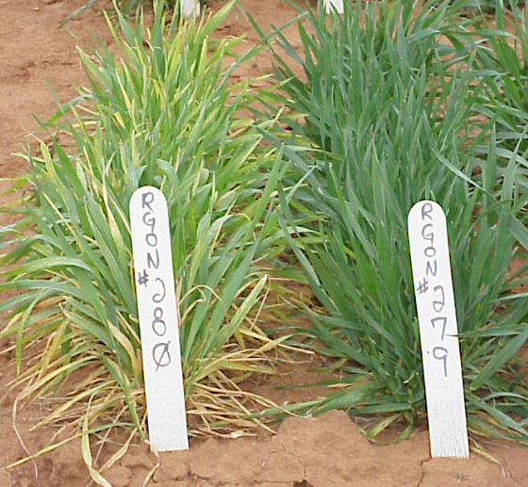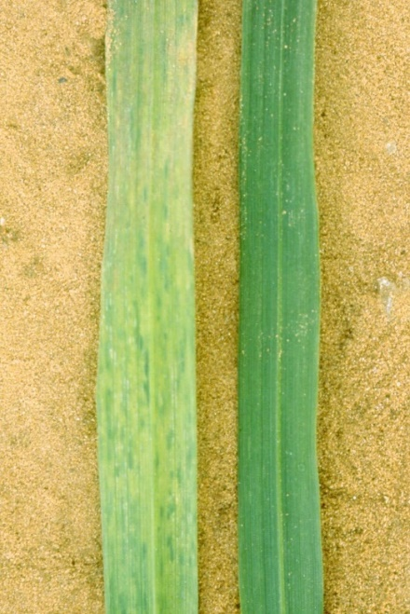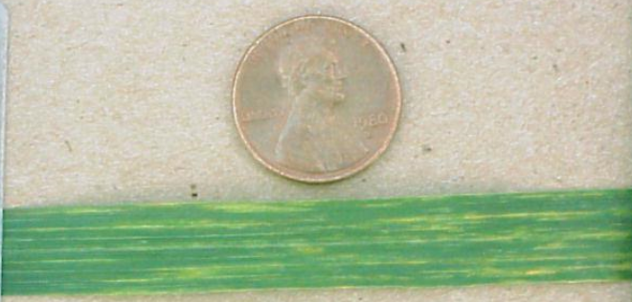

Across Oklahoma, I’ve received a report of tan spot in southwestern OK from Gary Strickland (County Educator, Jackson County; Figure 2), and also a report of rust from Josh Anderson (Senior Research Associate, Noble Research Institute, Ardmore, OK) in south-central OK near Ardmore. Josh did not indicate if this was leaf or stripe rust, but he did indicate it was on the variety Pete, which indicates to me it most likely was stripe rust. So far, no reports from Texas, but I would imagine disease incidence and severity will now start to increase.

Figure 2. Upper photo are symptoms on a wheat leaf indicative of Septoria or Stagonospora leaf blotch found near Stillwater on 13-Mar-2021. The lower photo is of a wheat leaf with symptoms indicative of tan spot observed in southwest Oklahoma by Gary Strickland, (County Educator; Jackson County), 3-11-2021.
