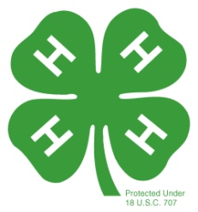
My 4-H Record Book

Attach (1) Photo

Name

Address City/State/Zip

Home Telephone Number Cell Number

Birthday 4-H Club

Grade in School Current Year in 4-H



Medals I Would Like To Receive: Medals I Have Already Received:
____________________________ __________________________ ____________________________ __________________________
____________________________ __________________________ ____________________________ __________________________
____________________________ __________________________ ____________________________ __________________________

The information contained within my record book is true and accurate to the best of my knowledge.

________________________ ___________________________
4-H Member 4-H Parent or Guardian

_____________________________ ___________________________
4-H Club Leader Extension Educator

Roger Mills County 4-H
4-H Project Award Areas

Petroleum Power
Automotive Photography
Achievement Plant & Soil Science
Agriculture Poultry
Arts & Crafts Public Speaking
Beef Rabbit
Breads Recreation
Citizenship Safety
Cats Sheep
Child Care Shooting Spots
Clothing Swine
Commodity Marketing Veterinary Science
Conservation Visual Arts
Consumer Education Wildlife & Fisheries
Consumer & Family Services Wood Science
Community Service
Dairy
Dairy Foods
Dog Care
Electric Energy
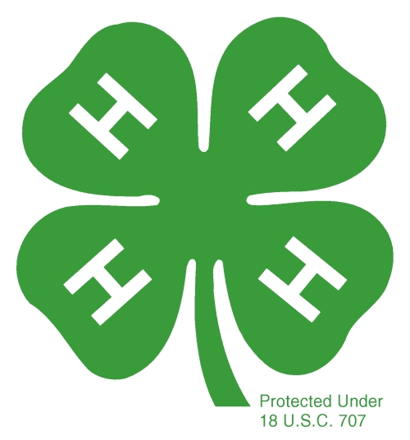
Entomology
Fashion Revue
Field Crops
Fitness Leadership
Food & Nutrition
Food Preservation
Forestry
Gardening
Goats
Hobbies & Collections
Home Environment
Horticulture
Health
Horse
Leadership
Pets
Performing Arts
Personal Development

4-H Record Book Instructions

Each year as record book times rolls around we get many last minute questions about record books. Some answers to frequently asked questions

Requirements for your Record Book:
●May be in either in a three ring binder or a stiff 8 ½ by 11-inch folder
●Record Books may be typed on computer; or handwritten
●Your Record Book must be signed by your 4-H leader before you turn it
into the OSU Extension Office.

A record book is just that. You record all your 4-H activities for the year, plus any other Leadership/Citizenship or non-4-H activities in which you participated since your last record book was completed.

What is a 4-H Project: A project is a subject or topic that you learn about in 4-H which results from knowledge and skills you learned in the project. You learn about your project from attending club meetings, educational workshops, and working with adult leaders and other 4-H members. You can also learn from field trips and camps, by participating in shows and competitions, as well as through family and self study.

Why complete a 4-H Record Book? A record book is not meant to be a chore. Instead it is a way for you to learn. Here are some important reasons why you should complete a 4-H Record Book for your projects.
Keeping a 4-H Record Book will help you:
- Learn how to organize yourself
- Learn how to use project objectives to set goals and plan your project work for the year
- Learn how to set reasonable goals for yourself
- Appreciate and explain what you’ve learned this year in your project work
- Gather information needed to apply for awards
- Meet requirements to participate in some county and state 4-H events
- Did you participate, organize or lead?
- Was the activity initiated by 4-H or another group?
- One aspect of a 4-H activity may be project work and another aspect leadership.

What is a 4-H Story? This is one of the most important pages in your book.
These are some examples of what should be in your 4-H story.
- It should tell your reason for being in 4-H
- Tell about yourself, your family and things you like to do
- What you have learned in your project(s)
- Personal goals you have set for your years as a 4-H member
- Do you want to become a professional seamstress and that is why you chose clothing construction as your project?
- Do you want to own a day care center or teach young children and that is why you chose childcare as your project?
- Do you want to work for the pork industry and that is why you chose to have a swine project?
- Do you want to work for a cow-calf operation and that is why you chose your beef cattle project?
- How will being a 4-H member help you in the future?
- What benefits do you get from membership?
- As you progress in age, your 4-H story should become more detailed.

What is the Photo (picture) page(s):

- Photos are an important part of keeping records – whether for a 4-H Record Book or for future references
- Photo pages are limited to 3 pages with 3 pictures to a page.
- To be effective, photos should show people doing something and their involvement in project work, leadership and/or community service activities.
- They should have descriptive captions and they should be presented attractively.
- Use captions to explain the activities in the photo.
- A caption is a short description of the activity in your photo. Informative captions can indicate your knowledge of the project or provide additional information that is not already stated. The caption should indicate personal involvement. Use captions to explain something important about the photo that may not be easily understood by someone who is not familiar with your project.

Participation in Events and Activities Year 2020-2021

Name of event activity or exhibit | L | C | D | S | Placing or award
Example: Participated in the County 4-H Speech Contest …“How to be a good Citizen” |  | 15 |  |  | Blue Award Champion
Example: Exhibited my swine project at the County Spring Livestock Shows |  | 175 |  |  | 1st, Champion Grand Champ.

Things I learned in my 4-H Project(s) Year 2020-2021

LIMITED to ½ Page
Examples: * I learned to measure ingredients carefully. **I learned to keep fresh water and feed out for my animal so it would be healthy and gain weight.

Project(s) Expenses and Income

LIMITED to ½ Page
Examples: *I purchased my swine project for $150.00.
**I placed 1st at the County Spring Livestock Show and receive $7.00
***At the County Bonus Auction my animal received $300.00.
Leadership and Citizenship in all Projects Year 2020-2021
LEADERSHIP LIMITED to 1/2 Page
List leadership activities you have been involved in. Leadership is defined as one-on-one assistance, organizing an activity, teaching a workshop, holding an office, serving on a committee, etc.
Description of activity | L | C | D | S | # of Hours | Number Reached
Example: Lead the pledge at local club meeting | 10 |  |  |  | 1 | 10

CITIZENSHIP LIMITED to ½ Page
List the citizenship/community service activities you have been involved in. Include activities that benefit an individual, a non-4-H group or the community. May include activities that exhibit the qualities of a good citizen.
Description of activity | L | C | D | S | # of Hours | Number Helped
Example: Organized my local 4-H Club to make cards to send to the troops. (You are representing your 4-H Club.) | 7 |  |  |  | 1 | 7

4-H Awards and Special Recognition Year 2020-2021

LIMITED to ½ Page
Type of Award or Recognition | L | C | D | S
Example: Roger Mills County Bonus Auction participant |  | 175
Example: Outstanding Junior 4-H Camper |  |  | 125
Example: High Participation Award winner |  | 95

Non-4-H Experiences

LIMITED to ½ Page
List your most meaningful non-4-H experiences including participation in school, church/faith or community organizations

Type of Activity, Award or Recognition | L | C | D | S
Example: Organized my Sunday School class at church to make cards to send to the troops. (You are representing your church not 4-H.) | 25
My 4-H Story – LIMITED to 2 pages
In your own words, tell about yourself, your project work, leadership and citizenship experiences and highlights of the 4-H year.

_________________________________________________________________

_________________________________________________________________

