2025

September 4, 5, & 6

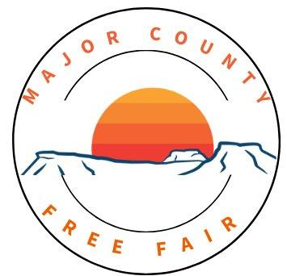

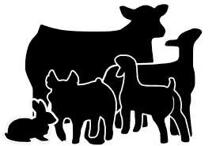
Horse, Poultry, Rabbit and Livestock Only

4-H & FFA Exhibitors:
To be eligible for the 2026 bonus auction, you must enter at least one animal; or enter two exhibit in the 4-H/FFA non-livestock division (whichever organization you are a member of); or participate in the livestock judging contest and enter one exhibit in the 4-H/FFA non-livestock division.

TABLE OF CONTENTS

Message to 4-H & FFA Exhibitors 1
Fair Dedication 3
Schedule, Fair Board & County Commissioners 4
Excise Board and Extension Staff 4
Welcome & Important Information 4
Announcements, General Rules 5
Entry Rules, Awarding Committee 6
Protests & Appeals 6
Code of Ethics 7
Major County Fair Horse Expo 8
Open Class Livestock, Beef Classes 9
Bucket Calf, Dairy, Sheep, and Swine 10
Goat, Special Needs Livestock Show 11
Poultry 11
Rabbits 14
Michelle Nichols Memorial Livestock Award 15
Major County Junior Livestock 4-H/FFA 15
Pre-Entry Information 19

Exhibitor Pre-Entry Forms Provided at OSU Extension Office, online at: http://extension.okstate.edu/county/major/major-county-fair-and-shows.html, or on the following Facebook pages: Major County Fairgrounds, Major County OSU Extension

The 2025 Major County Fair is dedicated to (the late) David and Ronda Frech

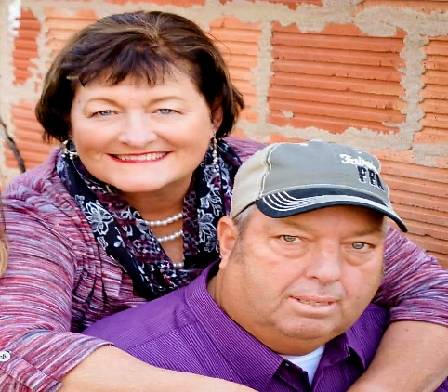

With David’s passing in 2024, he is deeply missed by not only his family and friends, but his community- Major County and beyond. David was a servant at heart, volunteering 23+ years on the Major County Fair Board where he held offices of president, vice president, and treasurer. He engaged in many of the facility changes at the fairgrounds, and improvements in both the county fairs and junior livestock shows. David was instrumental in starting the trophy/awards auctions that continue to benefit our county youth. He also volunteered prior to serving on the fair board and was always available when needed and helped as he could as long as his health allowed.
Ronda continues to serve as a volunteer superintendent for the photography division at the Major County Fair as she has for many years. She has also helped for over 25+ years with parts of the fair such as the free meals and 4-H concession stands at the county fairs and as well as the junior livestock shows and bonus auctions. She has been a member of the Busy Bees OHCE group since 1991.
David and Ronda were both active volunteers in both the 4-H and FFA programs while raising their children Darinda, Drew, and Darin at Fairview. David was a proud supporter; and Ronda continues to be a supporter of the programs while watching their grandchildren participate.
We are grateful for the dedication that David had and appreciate Ronda’s continued service.

MAJOR COUNTY FAIR SCHEDULE
Monday, August 4 to Friday, August 29, 2025, 8:30a.m.-12:00pm and 1:00pm-4:30p.m. All exhibits must be pre-entered, and all tags must be picked up by 4:30p.m. on Wednesday, September 3 at the OSU Extension Center.

THURSDAY, September 4
10-11:00a.m. - OHCE & Volunteer entries received
12-7:00p.m.- Non-livestock Entries received
(Bring items with entry tags already attached)
2-7:00p.m.- Vendor booth set-up
5-7:00p.m.- OHCE Fried Onion Burger Special
5-7:00p.m - Poultry and Rabbits entered and tested.
5:30p.m. - Horse Expo
7:00p.m. - Poultry and Rabbits Judged

FRIDAY, September 5
7:30a.m.- OHCE Concession Stand open
8:00a.m.- All livestock to be in place
8:30a.m.- Sheep and Goat Weigh in and Cards Due
9:00a.m.- Vendor Booths Open
9:00a.m.- Judging of all non-livestock entries
10:00a.m.- Livestock Judging Contest
12:30p.m.- Special Needs Livestock Show
2:00p.m.- Sheep Show followed by Goat Show
4:00p.m.- Poultry and Rabbits Released
5-7:00p.m.- OHCE Indian Taco Special
4:00p.m.- Swine and Beef Weigh-In and Cards due

SATURDAY, September 6
7:30a.m.- OHCE Concession Stand Open
10:00a.m.- Vendor Booths Open
10:00a.m.- Swine Show, Bucket Calf Show to follow
12:00p.m.- Free Lunch
1:00p.m.- Beef Show
2-4:00p.m.- All Exhibits Released

Major County Fair Board
Kyndell Nichols- President
Justin Thomas- Vice President
Jeff Bedwell- Member
Greg Hiebert- Member
Hollie Kuehni- Member
Grant Whipple- Member
Carri Pike- Member
Cale James- Member
Darin Frech- Member
Shellie Ragan Secretary

County Commissioners
Ryan Greb- District 1
Rusty Thomas- District 2
Travis Darr- District 3

County Excise Board
Byron Hobson
Ryan Sproul
Mitch Zimmerman

County Extension Staff
Dana Baldwin- County Extension Director, FCS/4-H Educator
Jamie Locke- Extension Admin Support Specialist

WELCOME TO THE
MAJOR COUNTY
FREE FAIR!
IMPORTANT!!
ALL ITEMS ENTERED IN THE FAIR MUST BE PRE-ENTERED.
Pre-entry: August 4-29, 2025, at the Major County OSU Extension Office.
(All horse show and poultry tags must be picked up no later than 4:30p.m. on Wednesday, September 3.)

*See page 19 for Pre-Entry Information
Announcements

The board of the Major County Free Fair announces that the annual Free Fair will be held at the Major County Fairgrounds in Fairview, Oklahoma, on September 4, 5, and 6, 2025. A properly conducted Free Fair should and does result in more economical production. No one factor does more to stimulate effort in improving fair conditions than the fair. It is there that the exhibitor has the opportunity to see and observe the progress being made in the improvement of farm crops, animals, and other exhibits and to compare their work with the efforts of others. Their success in competing with their neighbors stimulates them to greater efforts and their failures teach them where their work has been at fault. The success of the Free Fair depends greatly upon the efforts of various entities. The Fair Board will spare no pains to make everything pleasant and as comfortable for the public as it is possible to do. Remember, this is a free fair—no admission is charged. It is your fair. With the right kind of cooperation, the Major County Free Fair will be second to none in the state.

Major County Fair Board

General Rules
- The Major County Fair Board of the Major County Free Fair reserves the right to interpret the rules and regulations and to arbitrarily settle all questions. In connection with the fair.
- The management reserves the right to amend or add to these rules, as they deem necessary or advisable without further notice. In the event of conflict with general and special rules, the latter will govern.
- All exhibitors must be residents of Major County, a member of a Major County 4-H Club, FFA Chapter, FCCLA Chapter, a bona fide member of a Major County OHCE Group, or attend a Major County School or reside in a Major County School District.
- All property of every character entered for competition or display, or for any other purpose, will be subject to the control of the Fair Board, but in no case shall the Fair Board or any of its officers be held responsible for any loss, damage, or injury to any character of to any such property while same is under the control of the Fair Board.
- Exhibitors of livestock will be required to keep their stall open, clean and in order and their stock accessible to visitors at all reasonable hours during the Free Fair.
- The Major County Fair Board WILL NOT BE RESPONSIBLE FOR any accidents or injury to any exhibitor or any other persons attending the Major County Free Fair.
- No Junior exhibitor (4-H or FFA) will be allowed on the fairgrounds after 11:00p.m. without written permission of parents AND Extension Director or Ag Instructor.
- If any article has been entered in any previous Major County Free Fair, it is not eligible to compete in the 2025 Free Fair.

Entry Rules
- Articles not listed will not be exhibited.
- All entries must be pre-entered.
- No article or animal will be allowed to enter except in the name of its bona fide owner. Each exhibitor must show his or her own animal, except in case of illness or school function conflict.
- All exhibits of crops must have been grown during the year 2025 crops.
- The Fair Board will furnish judges in all departments. The Fair Board reserves the right to substitute judges in case of necessity.
- ALL EXHIBITS ARE REQUIRED TO HAVE AN ENTRY CARD FOR LIVESTOCK, AND/OR AN ENTRY TAG FOR ALL POULTRY, RABBITS, NON-LIVESTOCK ENTRIES. HORSE EXPO ENTRIES WILL HAVE BACKTAGS. Livestock Entry cards will be provided. Exhibitors are required to see that their exhibits are properly tagged and entered. It is the responsibility of the exhibitor to see that all information on the entry tag is correct. Cards can be obtained at the Fair Office. Actual exhibits (excluding livestock) will be brought to the fairgrounds on Thursday, September 4, between 12:00p.m. and 7:00p.m. (See livestock rules for details). Entry tags for non-livestock, poultry, rabbits, and horse back tags entries will be available after pre-entries are made, during the specified time, at the OSU Extension Center, and must be picked up by 4:30p.m. on Wednesday, September 3.

Awarding Committee
- When there is no competition, the judges will specify whether the article is worth the class. Awards will be given by the single judge system. No appeal will be considered except in case of protest.
- When special premiums are offered, they shall be paid directly by the donor.
- All judges and award committees must be wholly disinterested directly or indirectly in the decisions which they may have voiced.
- Interference with judges is not allowed. When judges have carefully examined all articles and decided, the superintendent of the department will promptly mark the results and attach ribbons to the exhibits until the conclusion of the Free Fair.

Protests & Appeals
- All protests must be made in writing and accompanied by a deposit of $50.00, which will be forfeited if protest is not sustained. Said protest must state plainly the cause of the complaint or appeal and name and address of witnesses must be filed with the secretary of the Fair Board who in turn shall refer it to the Major County Fair Board whose decision shall be final. The protest of appeal must be made within 24 hours after the award is made.

- The right of an exhibitor to appeal from the decision of a judge to the Board can only happen when it is charged that the award has been made in violation of the rules governing the exhibit or when it is charged that the decision of the judge has been influenced or interfered with by another.
- In addition to the rights to protest herein guaranteed to exhibitors, the Fair Board reserves the right to take cognizance of fraud, consummated or attempted, in connection with an exhibit and take such action as may be deemed just and proper and as may be warranted in the premises.

Code of Ethics
Believing it is in the best interest of all exhibitors to maintain a reputation of integrity and to continue to present a wholesome and progressive image in the show ring, the following list of practices are considered unacceptable in the presentation of livestock. The use of such practices of procedures is, therefore, considered a violation of the Rules & Regulations governing the show. The official code of ethics of the Oklahoma State Fair Handbook, will be followed including, but not limited to:

- Misrepresentation of the age or breed of the animal for the class in which it is entered.
- Striking the animal to cause swelling.
- Any attempt to change the natural color of an animal.
- Administration of a drug of any kind except for the treatment of a recognized disease or injury.

MAJOR COUNTY FAIR
HORSE EXPO
THURSDAY, September 4, 2025, 5:30p.m. Halter and Showmanship classes will be held in the Expo Center at the Major County Fairgrounds; Horsemanship and Trail classes will be held at the Fairview Wranglers Arena.
ALL EXHIBITORS must be pre-registered! Pre-Registration is required anytime between 8:30 a.m. on Monday, August 4 to 4:30 p.m. on Friday, August 29. Pre-entry must be completed by 4:30 p.m. on Friday, August 29. (STICK HORSE RACE entries do not have to pre-enter.)

RULES
    - CURRENT NEGATIVE COGGINS REQUIRED (a copy must be turned in with pre-entry. Pre-entry will not be accepted without it.)
    - NO STALLIONS ALLOWED
    - Exhibitors must be a resident of Major County, belong to a Major County 4-H or FFA Club, attend a Major County School, or reside in a Major County School District.
    - A liability release has to be signed by each exhibitor or the exhibitor’s legal guardian if under 18 years of age (on entry form).
    - JUDGE’S DECISION IS FINAL.
- Premiums will be paid for 1st, 2nd, and 3rd places in each class.
    - Oklahoma State 4-H Horse show rules will apply.

    - The rulebook is available for review at the Major County OSU Extension Office, or you may access it online at https://extension.okstate.edu/programs/horse/4h-events
    - Ownership of the horse is not necessary, but a horse may not compete more than once per class.
    - Exhibitors must wear a collared shirt, jeans, and boots. Hat is optional. No ballcaps.
    - All exhibitors must have full control of their horse AT ALL TIMES and must be appropriately skilled to handle their horse safely and in a sensible manner.
    - An exhibitor may be excused from the arena by show management for unruly/dangerous behavior.
    - Show management may suspend an exhibitor's right to participate in any class or disqualify an exhibitor for poor sportsmanship, unruly/dangerous behavior, inhumane treatment of their animal.

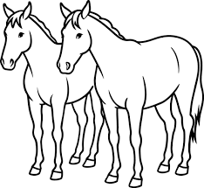

High Point Qualifications:
(to be given to PEEWEE, JUNIOR, AND SENIOR age groups)
1. One Horse/One Rider- the same horse for all events.
2. Must enter a halter class as well as all other classes.

Horse Classes
  - HALTER- MARES
  - HALTER- GELDINGS
  - SHOWMANSHIP- PEEWEE
  - SHOWMANSHIP- JR.
  - SHOWMANSHIP- SR.
  - SHOWMANSHIP- OPEN
  - HORSEMANSHIP- PEEWEE
  - HORSEMANSHIP- JR.
  - HORSEMANSHIP- SR.
  - HORSEMANSHIP- OPEN
  - TRAIL- PEEWEE
  - TRAIL- JUNIOR
  - TRAIL- SENIOR
  - TRAIL- OPEN

STICK HORSE RACE
(ages 5 & under)
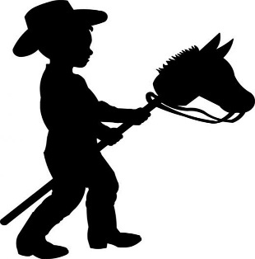
Race will be at 5:15p.m. in the Expo Center at the Major County Fairgrounds. Entries do not have to pre-enter.

OPEN CLASSES
-ALL EXHIBITS must be pre-registered! Pre-Registration is required anytime between 8:30 a.m. Monday, August 4 to 4:30 p.m. on Friday, August 29. Pre-entry must be completed by 4:30 p.m. on Friday, August 29.

Open Class
Livestock
- All breeding animals must conform to breed qualifications.
- No limit on number of entries.
- Show order will be youngest classes first.
- Open show will precede the junior livestock show.
- Champions will receive a ribbon.

Beef Classes
Breeds: Angus, Hereford, Shorthorn, Other Purebred Breeds
B1 Bull, over 4 months and under 1 year
B2 Bull, 1 year and under 2 years.
B3 Bull, 2 years and older.
CHAMPION BULL

B4 Heifer, 4-12 months
B5 Heifer, 12-18 months
B6 Heifer, 18-24 months
B7 Cow, 2 years and older CHAMPION FEMALE

B8 Peewee Showmanship, ages, 8 and under

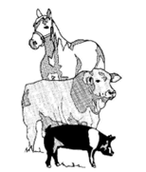

BUCKET CALF
An orphaned or newborn calf, male or female dairy or beef, hand-fed on a bucket or bottle. Must be weighed in at designated site. Youth under 4 to 8 years of age may participate. Youth may only have one entry.
Judging will be based on record forms, evaluation by a judge on the care and knowledge obtained, and interest shown by the participant. Awards will be presented to participants.
*See entry forms for more details.
ALL exhibits in this department must be pre-registered! Pre-Registration is required anytime between 8:30 a.m. on Monday, August 4 to 4:30p.m. Friday, August 29.

Dairy Classes
D1 Bull, over 4 months and under 1 year
D2 Bull, 1 year and under 2 years
D3 Bull, 2 years and older
D4 Heifer, 4-12 months
D5 Heifer, 12-18 months
D6 Heifer, 18-24 months
D7 Cow, 2 years and older
CHAMPION FEMALE

D8 Peewee Showmanship, ages 8 and under

Sheep Classes
S1 Ram, 4-12 months
S2 Ram, 1 year and older
CHAMPION RAM

S3 Ewe, 4-12 months
S4 Ewe, 1-2 years
S5 Ewe, 2 years and older
CHAMPION EWE

S6 Peewee Showmanship, ages 8 and under

Swine Classes
Must have a negative pseudo rabies test after June 1, 2025, must have an official ear tag in the right ear and premise identification number.

SW1 Boar, 4-7 months
SW2 Boar, 8 months and older
CHAMPION BOAR

SW3 Gilt, 4-7 months
SW4 Sow, 8-18 months
SW5 Sow, 19 months and older
CHAMPION FEMALE

SW6 Peewee Showmanship, ages 8 and under
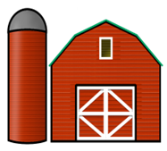
Goat Classes
G1 Get of Sire
G2 Wether, not over 10 months
CHAMPION MALE

G3 Doe, birth-4 months
G4 Doe, 5-12 months
G5 Doe, 13 months-2 years
G6 Doe, over 2 years in milk
G7 Doe, over 2 years un-freshened
CHAMPION FEMALE

G8 Peewee Showmanship, ages 8 and under

Special Needs Livestock Show
The show will begin at 12:30pm on Friday, September 6, 2025.
Participants will be Major County youth, grades 3 to 12, with disabilities/special needs assisted by 4-H or FFA livestock exhibitors who volunteer themselves and their sheep or goat.
The purpose of this show is to offer the livestock showing experience to those who may normally find hurdles in being able to participate.
Each participant in the show will receive an award provided by generous sponsors.
(Both the participants and assistants will need to have release forms signed by a person over the age of 18.)

POULTRY DEPARTMENT
- Exhibitors must be a resident of Major County, belong to a Major County 4-H or FFA Club, attend a Major County School, or reside in a Major County School District.
- All exhibitors will abide by the general rules & regulations of the Major County Fall Free Fair.
- Exhibitors must have owned and personally cared for their poultry at least 30 days prior to the day of the show.
- Exhibitors can enter 1 entry per class. And must enter using the Poultry and Rabbit Paper Entry Form (NEW 2025)
- All poultry entries must be of a recognized breeds. Birds of a breed not listed will show in the Other Standard Breeds Class.
- All breeds must be pre-determined by exhibitors AND BE WRITTEN ON THE ENTRY FORM AT THE TIME OF ENTRY.

- Cock- Male bird, 12 months or older
- Hen- Female bird, 12 months or older
- Cockerels- Male bird less than 12 months old
- Pullet- Female bird less than 12 months old
- Trio- consists of a cock and two hens, or cockerel two pullets of the same variety.
- All poultry exhibited shall be free of visible evidence of disease.
- Exhibitors will furnish their own feeders and water containers and should feed, water, and clean cages as necessary.
- All entries will be required to take a blood test
- A state-certified poultry tester will be present to take blood samples. The Major County Free Fair will pay the testing fees.
- JUDGE’S DECISION IS FINAL.
- All entries in this division will be released at 4:00 PM on Friday, September 5th.
- Premiums will be awarded to the 1st, 2nd, and 3rd place finishers in each class.

LARGE (Standard Size) CHICKENS Breeds
American Class-
Division P1
Buckeye, Chantecler, Delawares, Dominique, Holland, Java, Jersey Giant, Lamona, New Hampshire, Plymouth Rock, Rhode Island Red, Rhode Island White, Wyandotte

C1 Cock
C2 Hen
C3 Cockerel
C4 Pullet
C5 Young Trio

Asiatic Class-
Division P2
Breeds Include-Brahma, Cochin, Langshan

C6 Cock
C7 Hen
C8 Cockerel
C9 Pullet
C10 Trio

English Class-
Division P3
Australorps, Cornish, Dorking, Orpington, Redcap, Sussex

C11 Cock
C12 Hen
C13 Cockerel
C14 Pullet
C15 Trio

Mediterranean Class:
Division P4
Anconas, Andalusians, Catalina, Leghorn, Minorca, Sicilian Buttercup, Spanish

C16 Cock
C17 Hen
C18 Cockerel
C19 Pullet
C20 Trio

Continental Class-
Division P5
Barnevelders, Campine, Crevecoeur, Faverolles, Hamburg, Houdan, LaFleche, Lakenvelder, Marans, Polish, Welsummer

C21 Cock
C22 Hen
C23 Cockerel
C24 Pullet
C25 Trio
All Other Standard Breeds Class-
Division P6
Ameraucana, Araucana, Aseel, Cubalaya, Malay, Modern Game, Naked Necks, Old English Game, Phoenix, Shamo, Sultan, Sumatra, Yokohama

C26 Cock
C27 Hen
C28 Cockerel
C29 Pullet
C30 Trio

Bantam Chicken Breeds:
Modern Game
Division P7
BC1 Cock
BC2 Hen
BC3 Cockerel
BC4 Pullet
BC5 Trio

Old English Game-
Division P8
BC6 Cock
BC7 Hen
BC8 Cockerel
BC9 Pullet
BC10 Trio

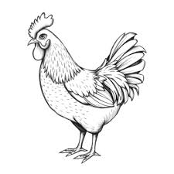
Single Comb Clean Legged-
Division P9
American Serama, Andalusian, Ancona, Australorp, Barnevelder, Campine, Delaware, Dorking, Dutch, Javanese, Junglefowl, Lakenvelder, Leghorn, Minorca, Naked Neck, Nankin, New Hampshire, Orpington, Phoenix, Plymouth Rock, Pyncheon, Rhode Island Red, Spanish, Sussex, Vorwerk, Welsummer

BC11 Cock
BC12 Hen
BC13 Cockerel
BC14 Pullet
BC15 Trio

Rosecomb Clean Legged-
Division P10
Anconas, Belgian D’Anver, Dominique, Dorking, Hamburg, Leghorn, Nankin, Rhode Island Red, Rosecomb, Sebright, Watermaal, Wyandotte

BC16 Cock
BC17 Hen
BC18 Cockerel
BC19 Pullet
BC20 Trio

All Other Clean Legged-
Division P11
Ameraucana, Araucana, Aseel, Buckeye, Buttercup, Chantecler, Cornish, Crevecoeur, Cubalaya, Houdan, Ko Shamo, La Fleche, Malay, Orloff, Polish, Shamo, Sumatra, and Yokohama

BC21 Cock
BC22 Hen
BC23 Cockerel
BC24 Pullet
BC25 Trio

Feather Legged-
Division P12
Belgian d’Uccle, Booted, Brahma, Cochin, Faverolle, Langshan, Silkie, Sultan
BC26 Cock
BC27 Hen
BC28 Cockerel
BC29 Pullet
BC30 Trio

Ducks
Division P13
D1- Heavy Class: (Breeds Include) Appleyard, Aylesbury, Muscovy, Pekin, Rouen, Saxony
D2- Medium Class: (Breeds Include) Buff, Cayuga, Crested, Swedish
D3- Light Class: (Breeds Include) Campbell, Magpie, Runner, Welsh Harlequin
D4- Bantam Duck: (Breeds Include) Call, East Indie, Mallard

Geese
Division P14
G1- Goose
G2- Gander

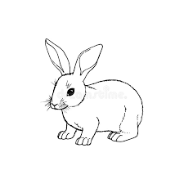
RABBIT
DEPARTMENT
Standard Rabbit Rules:
- Must be owned by the exhibitor for no less than 30 days prior to the show.
- Rabbits will show no signs of illness (crusty nose, sniffing, watery eyes).
- Rabbits must meet breed specifics mandated by the American Rabbit Breeders Association to show in breed or show in the AOB (pet class).
- Each exhibitor is limited to 2 does and 2 bucks maximum.
- Classes available for the following breeds: Californian, Dutch, Florida White, Havana, Holland Lop, Mini Lop, Mini Rex, Netherlands Dwarf, New Zealand, Polish, Thrianta, All Other Breeds (AOB)

Meat Rabbit Pen Rules
- The exhibitor must own/care for the rabbits starting 5 weeks before the show date.
- Meat rabbits can be purchased from any breeder.
- Breeds that are acceptable for show: Californian, New Zealand.
- Rabbit pens will be of the same breed and variety, but do not have to come from the same litter.
- An exhibitor will present a pen (3 rabbits) for evaluation and can only enter one pen per class.

RABBITS-
DIVISION P15
(Same for each breed)
R1 Senior Buck- 6 months and older
R2 Junior Buck- 6 months and younger
R3 Senior Doe- 6 months and older
R4 Junior Doe- 6 months and younger
R5 Meat Pen of 3

MICHELLE NICHOLS
MEMORIAL
LIVESTOCK AWARD
This award will be given annually to the top junior livestock exhibitor in Major County. The award will be based upon the highest placing of three animals from the free fair in the fall (30%) and the three highest placing animals from the spring junior livestock show (30%). Point cards will be due 30 minutes after each species is complete. Top exhibitors based on animal show points will participate in a 10-minute interview (40%). Showmanship placings will also be figured in from each county show event.
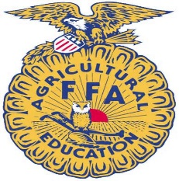


JUNIOR LIVESTOCK
DIVISION 4-H & FFA
*ALL EXHIBITS MUST BE PRE-ENTERED! Pre-Entry is required anytime between 8:30 a.m. on Monday, August 4 to and 4:30 p.m. on Friday, August 29. Pre-Entry must be completed by 4:30 p.m. on Friday, August 29.

- Each Exhibitor must be a bona fide member of a 4-H or FFA chapter in Major County by September 3, 2025.
- Exhibitors are encouraged to dress in species appropriate clothing; T-shirts, tennis shoes, and headwear are discouraged.
- Refer to schedule in front of book for all times.
- Exhibits must be owned and personally cared for, for a period of 90 days on steers, 30 days on prospect steers, 60 days on swine, sheep, and goats, and 30 days on breeding stock, by the exhibitor whose name it is entered. Exhibitors will not be permitted to enter livestock in open classes that they have shown or expect to show in the junior division.
- NO PAINT OR ARTIFICIAL COLORING IS ALLOWED TO BE USED ON ANY LIVESTOCK. ANY RESIDUE FROM PREVIOUS SHOWS MUST BE REMOVED.
- Exhibitors eligible for the showmanship award must show their own animal, exhibitors must be enrolled in 4-H or FFA in Major County and show in the junior division.

There will be 3 divisions:
Grade as of September 1
- Senior- Grades 9-12
- Intermediate- Grades 6-8
- Junior– Grades 3-5
- Two entry cards for sheep, beef, goats, and swine should be filled out with weight. One card will be turned in for entry and the second will be retained to present in the show ring upon completion of the class. Hogs must have pseudo-rabies number and premise ID number on the entry card.
- Market classes will be divided as evenly as possible with no class to exceed 8 entries.
- Any individual showing an animal for another junior exhibitor must be a member of a Major County 4-H or FFA Chapter.
- Animals will be released when all other exhibits are released.

BEEF
Show order: Heifers, Prospects, Markets, Showmanship

- Steers and commercial heifers will be shown by weight. Cards must be turned in by the designated time.
- NO PAINT, NO GLUE.
- Prospect steers will weigh 1000 pounds and under.
- Market steers will weigh 1001 pounds and over.
- Beef cards will be due at 4:00p.m. on Friday, September 5.
- Beef breeding classes consist of all purebreds represented. Heifers must be registered in the exhibitor’s name and papers must accompany entry. Commercial heifers will be weighed. Classes will be divided at the discretion of the beef superintendent.
- Bred and owned heifer show will begin at the conclusion of the regular heifer show– following breed guidelines.

HEIFERS
All heifers with papers will be offered a class as papered. Papered heifers will be shown by age. Commercial heifers will be shown by weight. Breeds will show alphabetically followed by AOB and Commercial. A minimum of 3 will be required to make a breed. All non-papered heifers will show as Commercial. Max heifer age is September 1 of 2023.

PROSPECT STEERS
The following breeds will be recognized with classes available for each breed. Breeds will show in the following order. The lightest weight of the class will show first.

Angus, Herford, Shorthorn, AOB

MARKET STEERS
Market Steers will be shown by division and broken by weight only. Other recognized breeds will be added, as needed. The lightest weight of class will show first.

DAIRY
- Dairy classes will be divided into two classes, heifers 12 months and under and heifers 13-24 months.
- The following breeds will be recognized with classes available for each breed. The youngest will show first.

Ayrshires, Brown Swiss, Guernsey Holstein, Jersey Milking, Shorthorn, Red Polled

GOATS
Show order: Does, Wethers, Showmanship

- Goats weight cards must be turned in by 8:30 a.m. on Friday, September 5, 2025.
- Classes will be divided by weight.
- Does and Wethers will show separately.
- All breeds will show together.

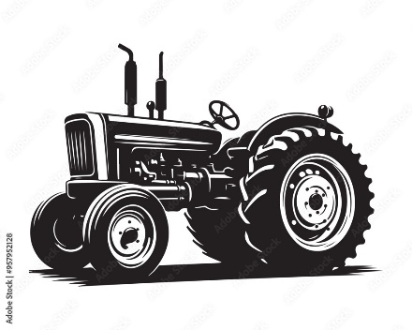

SHEEP
Show order:
Ewes, Wethers, Showmanship

- Market Wether weight cards must be turned in by the time the grand drive starts for the previous species. 8:30 a.m. Friday, September 5, 2025.
- EWES WILL SHOW AS BREEDING STOCK, NOT MARKET.
- Registration papers are required for ewe lambs.

EWE LAMB
The following breeds will be recognized with classes for each breed. All un-papered lambs will show as commercial. There will be a lamb and yearling lamb class. The youngest will show first.

Dorset, Hampshire, Shropshire,
Southdown, White-face

MARKET WETHERS
The following breeds will be recognized with classes for each breed. Lightest weights will show first.

Dorset, Hair, Hampshire, Natural Shropshire, Southdown,
White-face, Light Cross, Dark Cross

SWINE
- There will be no top weight limit.
- All swine exhibited at the Major County Free Fair must have a negative pseudo-rabies test after June 1, 2025, and must have an official ear tag in the right ear. The tag number must be on the entry card.
- All Swine cards are due by Friday, September 5, 2025, by 4:00pm. The Swine Show starts at 10:00a.m. on Saturday.

GILTS
The following breeds will be recognized with classes for each breed:

Berk, Chester, Duroc, Hamp,
Poland, Spot, York, Light Cross, Dark Cross

Registration papers are required to be eligible for these breeds. Classes to be broken by Age. Unregistered gilts will show as commercials, to be broken by weight.

BARROWS
The following breeds will be recognized with classes for each breed.

Berk, Chester, Duroc, Hamp,
Poland, Spot, York, Light Cross, Dark Cross
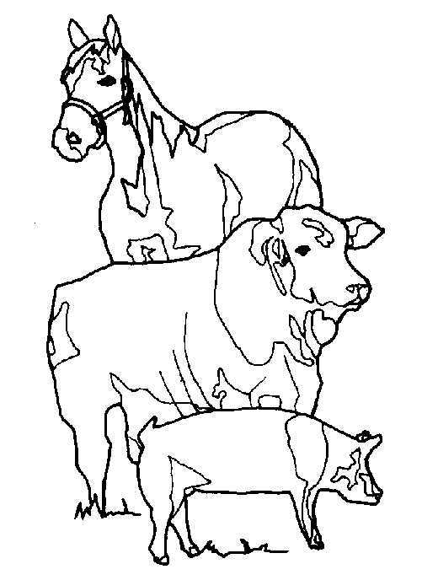

4-H & FFA
LIVESTOCK JUDGING

4-H Junior Division- Grades 3-7
4-H Senior Division- Grades 8-12
FFA Junior Division-Grades 8-10
FFA Senior Division-Grades 11-12
Categories will be:
Junior 4-H Individual
Junior 4-H Team
Senior 4-H Individual
Senior 4-H Team
Junior FFA Individual
Junior FFA Team
Senior FFA Individual
Senior FFA Team

PRE-ENTRY/ENTRY INFORMATION
ALL exhibits must be pre-entered! Pre-entry is required and will be received anytime between 8:30 a.m. to 12:00 p.m. and 12:30 p.m. to 4:30 p.m. Monday, August 4 to Friday, August 29, 2025, at the Major County OSU Extension Center located on the first floor of the Major County Courthouse in Fairview. Entries must be submitted by 4:30 p.m. on Friday , August 29. You may mail entry forms to be received by this time as well. Use the pre-entry forms provided.

AGAIN, ALL EXHIBITS entered into the Major County Free Fair must be pre-entered! This includes livestock, poultry, horse expo, and non-livestock entries.
You will be notified when your tags (Excluding livestock) are ready to be picked up. All tags must be picked up no later than 4:30 p.m. on Wednesday, September 3.

Bring your entries to the fairgrounds on Thursday, September 4, with the tags already attached between 12:00 p.m. and 7:00 p.m.

There is also an online entry option – contact the OSU Extension Center at 580-227-3786 for details.

Revised 7/21/2025

