
2025 – THIRD QUARTER
-Quarterly County 4-H Newsletter-
4-H Clover Connection

Major County OSU Cooperative
Extension Service

Address
500 E. Broadway, Courthouse Suite 3
Fairview, Oklahoma 73737

Phone
580-227-3786

Educators Email
Dana Baldwin, FCS/4-H & CED dana.baldwin@okstate.edu

Andrea Perkins, Ag/4-H
andrea.perkins10@okstate.edu

Website
https://extension.okstate.edu/county/major

Facebook
Major County OSU Extension

In this issue:
Page 2:
Enrollment for 2026-2027 Year
State Fair 4-H Indoor Exhibits
Facebook
4-H Concession Stand at Fair
ATV Riders Safety Course
County-Wide Meeting

Page 3:
District 4-H Leadership Conference
State Service Projects
ZZZ’s Under the Sea
Annual Awards Dinner
National 4-H Week

Page 4
Monthly 4-H Workshops
Livestock Meeting
Livestock Exhibitor Notice
Trophy Auction

Page 5:
Monthly 4-H Workshops

Page 6:
Family Fun Bowling Night

Page 7
2026 Major County Fair
Take Aim with Slingshots in Oklahoma 4-H Shooting Sports
Oklahoma 4-H Shooting Sports is introducing a new opportunity for youth with the addition of a slingshot discipline, launching in August. The program introduces participants to a fun and accessible shooting sport while expanding the range of disciplines offered in Oklahoma 4-H.
The slingshot discipline was developed by Mississippi 4-H, and Oklahoma is the first state to partner with Mississippi to bring the program to more 4-H’ers.
“The low cost and beginner-friendly format were an instant draw to the program,” said Ruth Pratt, Oklahoma 4-H Shooting Sports coordinator.
Training for 4-H volunteers begins Aug. 1, and 4-H’ers can start participating once their county has a certified instructor. The discipline is open to youth ages 9 and older and features a woods course, speed course, and a written test to build both practical skills and knowledge.
The program emphasizes affordability and accessibility. Slingshots typically range in price from $10 to more than $50, with most participants able to purchase a complete setup for $50 or less. Ammunition is made of biodegradable clay, and metal targets provide immediate feedback through audible hits and misses.
“When you say, ‘shooting sports,’ some people take a step back,” said Reid Nevins, Mississippi 4-H Shooting Sports coordinator. “But when something like this is available, they may be more apt to give it a chance. In that way, slingshot can serve as a bridge to other disciplines.”
Nevins and Winston County 4-H Agent Jim McAdory, who helped launch the program in Mississippi in 2025, were invited to Oklahoma in March 2026 to train the first group of Oklahoma instructors.
Volunteers interested in becoming a certified 4-H slingshot instructor or learning more about the program please contact the Major County OSU Extension Office.


4-H ARCHERY and SHOTGUN
The new seasons of 4-H Archery and Shotgun will be starting soon.
Practice and contest dates for archery are shared on the GroupMe app to those that are signed up (new ones can get signed up) and for shotgun via texts.
If you are a returning or new Archery and/or Shotgun participant, make sure to get re-enrolled/enrolled for the new 4-H year and be sure that the medical information section is completed online in your ZSuites account as well. You can re-enroll/enroll starting August 1 on ZSuites.
There is a change this year in the required safety training which will make it easier for 4-H members. If you are interested and would like more information, contact the OSU Extension office.

4-H CONCESSION STAND
AT THE MAJOR COUNTY FAIR
Each 4-H club in Major County is asked to provide 4 dozen wrapped snacks (that will sell for $1 each) for the fair concession stand by Friday, September 11 at 10:00a.m. Please have at least one adult and one youth present at all times when your club is scheduled to work.

The work schedule is as follows:

Thursday, September 10
2:00 p.m. to 7:00 p.m.: Fairview

Friday, September 11
8:00 a.m. to 1:00 p.m.: Aline-Cleo
1:00 p.m. to close of events: Ringwood

Saturday, September 12
9:00a.m. to close of events: Cimarron

-H FOOD SHOWDOWN
◊ Do You Like To Cook?
◊ Do You Like To Create Your Own Recipes?
◊ Do You Enjoy Watching Food Shows Or Cooking Contests On TV?
If so, you might be interested in the 4-H Food Showdown Contest.
Teams of 2 or 3 members have the opportunity to prepare a dish to present to a team of judges.
Junior teams (grades 3 to 5) are given a basic recipe to prepare. Grocery items from a common pantry can be used to enhance the recipe or be served with the recipe item.
Intermediate teams (grades 6 to 8) given a secret ingredient and category. Groups make up their own recipe.
Senior teams (grades 9 to 12) are given a box containing one or more secret ingredients. The secret ingredients are used along with grocery items from a common pantry to create a dish.
Our County Contest will be Thursday, May 29 at 6:00pm. Registration will be due by May 20.
Anyone is interested in this project, please contact Dana for more details.
The top two junior, intermediate, and senior teams from the county can advance to the West District 4-H Food Showdown during Contest Day on July 1 in El Reno or Chickasha.

OKLAHOMA 4-H RISING LEADERS CONFERENCE
Are you a rising leader in 4-H? Attend the Oklahoma 4-H Rising Leaders Con- ference–

ENROLLMENT FOR
2026-2027 4-H YEAR
August 1 starts the new 4-H year!
Enroll at https://4h.zsuite.org/
If you are a RETURNING 4-H Member or Volunteer, log in with the email associated with your profile, update your information, and pay your enrollment fee (members). Please DO NOT create a new profile.

If you are a NEW 4-H Member or Volunteer, you will need to create a new profile and then complete your enrollment.

The $20 enrollment fee can be paid online (which is preferred and is the quickest way to complete enrollment) or by coming to the Major County OSU Extension Office and paying with cash, check, or card. Youth are not fully enrolled until the enrollment fee is paid.

If you have any questions, please call our office.



ATV Riders Safety Course
Are you interested in participating in an ATV Riders Safety Course at the Oklahoma Farm Bureau/Oklahoma 4-H training facility in Guthrie with your club? Groups are a maximum of 8 riders at a time. Call the OSU Extension Center for more details.

We will be hosting a Statewide 4-H
Invitational Archery Contest on May
17 at the county fairgrounds.

If you are interested in learning more about the ar- chery discipline, come observe on this day. We will begin competition at 9:30am.
2026 Major County Fair- September 10, 11 & 12
See the flyer in this newsletter with details!
Check FACEBOOK for Updates!

Be sure to check our Facebook page for regular updates: Major County OSU Extension

Information is shared on this page that may miss our news- letters as well as reminders for entry deadlines, etc.
State Fair 4-H Indoor Exhibits
First place exhibits in the non-livestock 4-H division at the county fair will go on to the OKC State Fair for judging on September 16. Those placing there will be on display in Oklahoma Expo Hall during the fair and will be back in the OSU Extension Center after lunch on September 27. Please have any items that you did not leave at the county fair to the OSU Extension Center by noon on Monday, September 14 (baked goods- by noon on Tuesday, September 15). Contact us with any questions.

can be prepared.

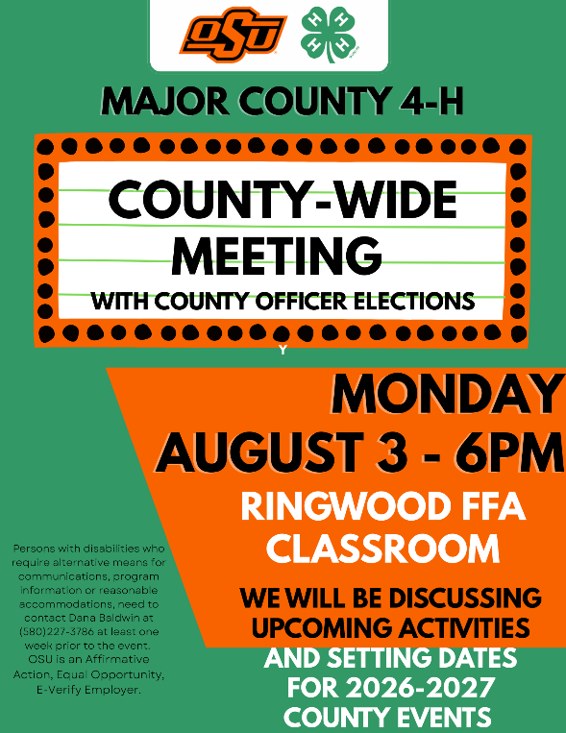



2026 ZZZ’s Under the Sea

Ever dreamed of snoozing with sharks or sea turtles? Join other 4-H members at the Oklahoma Aquarium in Jenks on September 11 and 12 for the ZZZs Under the Seas overnight event! You will get to see thousands of salt and freshwater fish and animals. See the LARGEST bull sharks in captivity through a one-of-a-kind walk-through tunnel, plus thousands of other captivating creatures, including sea turtles, seahorses, jellyfish, and eels. If sharks aren’t your idea of a relaxing night’s sleep, then feel free to slumber in any of our other approved areas. The fun-filled night begins with check-in on Friday at 7:00 p.m. and includes a light snack, drinks, a self-guided tour, and then sweet sea-themed dreams, a light breakfast is provided before you depart on Saturday at 7:00 a.m.
The cost is $50 per person. Registration fees are paid by credit card through ZSuites at: https://4h.zsuite.org/external-event-registration/50782
Members attending must be accompanied by adult chaperones.

West District
4-H
Leadership Conference

State 4-H Roundup just wrapped up in Stillwater on July 24 and it is exciting that Major County attended with a group of members that got to attend many workshops, participate in contests, have fun at different activities, and meet new people. With a new year getting ready to start in 4-H there are different leadership activities that will be available to 4-H members. One of those is West District 4-H Leadership Conference!
West District 4-H Leadership Conference will be October 14, 14 & 16 and is open to 7th to 12th graders for the 2026-2027 year. All eligible members are encouraged to take advantage of this opportunity and attend this event- you will not be disappointed!
This is a great opportunity to learn and grow with other members from across the district. The goal of the conference is to share and learn ideas and information that can be brought back to the local 4-H clubs and the county as well as improve the 4-H member themselves.
This is also the time that district 4-H officers are elected if anyone is interested in applying for or learning more about those opportunities as well.
Keep your eyes open for registration information that will be coming soon.

ANNUAL AWARDS DINNER
The annual Major County 4-H Awards Dinner to recognize members who submitted county record books is scheduled for Tuesday, September 1 beginning at 6:00pm in the Exhibit Building at the fairgrounds. Everyone is welcome to attend.

National 4-H Week
We will be celebrating National 4-H Week October 4 to 10 and Oklahoma 4-H Month during the entire time in October. Be thinking of how you as members and volunteers can help promote this organization!
Some ideas could be to offer a coloring contest or a poster contest or do some service projects in your communities.
STATE SERVICE PROJECTS
“Change for Change”
Change collected benefits the Oklahoma Children’s Hospital Foundation for supporting specialties such as cancer, genetics, autism, and infectious diseases. Collect change at your 4-H meetings or other events and turn it into the OSU Extension Center where it will then be sent to the State 4-H Office.
“Pull for Kids”
Collect pop tabs to support the Oklahoma City Ronald McDonald House. Turn tabs into the OSU Extension Center. You are encouraged to collect the entire can and use the money to support your 4-H club, but we only want the tabs turned into us. The tabs will be sold and the money sent to the State 4-H Office for distribution to the Ronald McDonald House.

Livestock Exhibitors:

To be eligible for the 2027 Major County Jr. Livestock Show Bonus Auction you must enter at least one animal, or two exhibits in the 4-H or FFA non-livestock division (whichever organization you are a member of), or participate in the livestock judging contest and enter one exhibit in the 4-H or FFA non-livestock division (whichever organization you are a member of).

Be sure and get your entries in- we’ll see you at the Major County Fair!

Attention All 4-H Livestock Exhibitors!!!

Beginning with a first meeting on Wednesday, August 26 at 6:00pm at the fairgrounds, there will be Livestock Exhibitors Informational Meetings/Educational Workshops for 4-H members offered every other month.

Come learn about show requirements, care and selection of livestock, and more.

Make plans to attend and look for future dates to be announced as well!

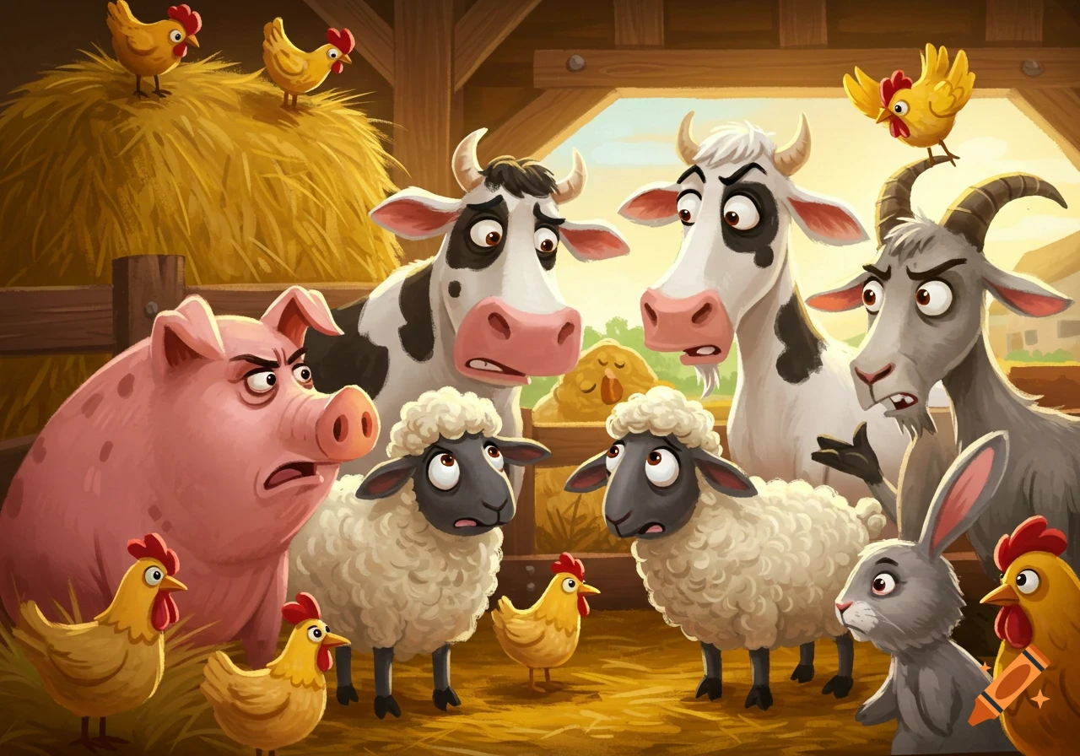
Monthly 4-H Workshops

Check out the flyer with the remaining monthly 4-H workshops for this year!

The next one coming up is Wednesday, August 19 at 6:00pm and the STEM activity is tie-dying t-shirts! If you plan to attend, please call our office soon as there is a limited number of spaces. We will need your t-shirt size as well.

Make plans now for the rest of the workshops as well!



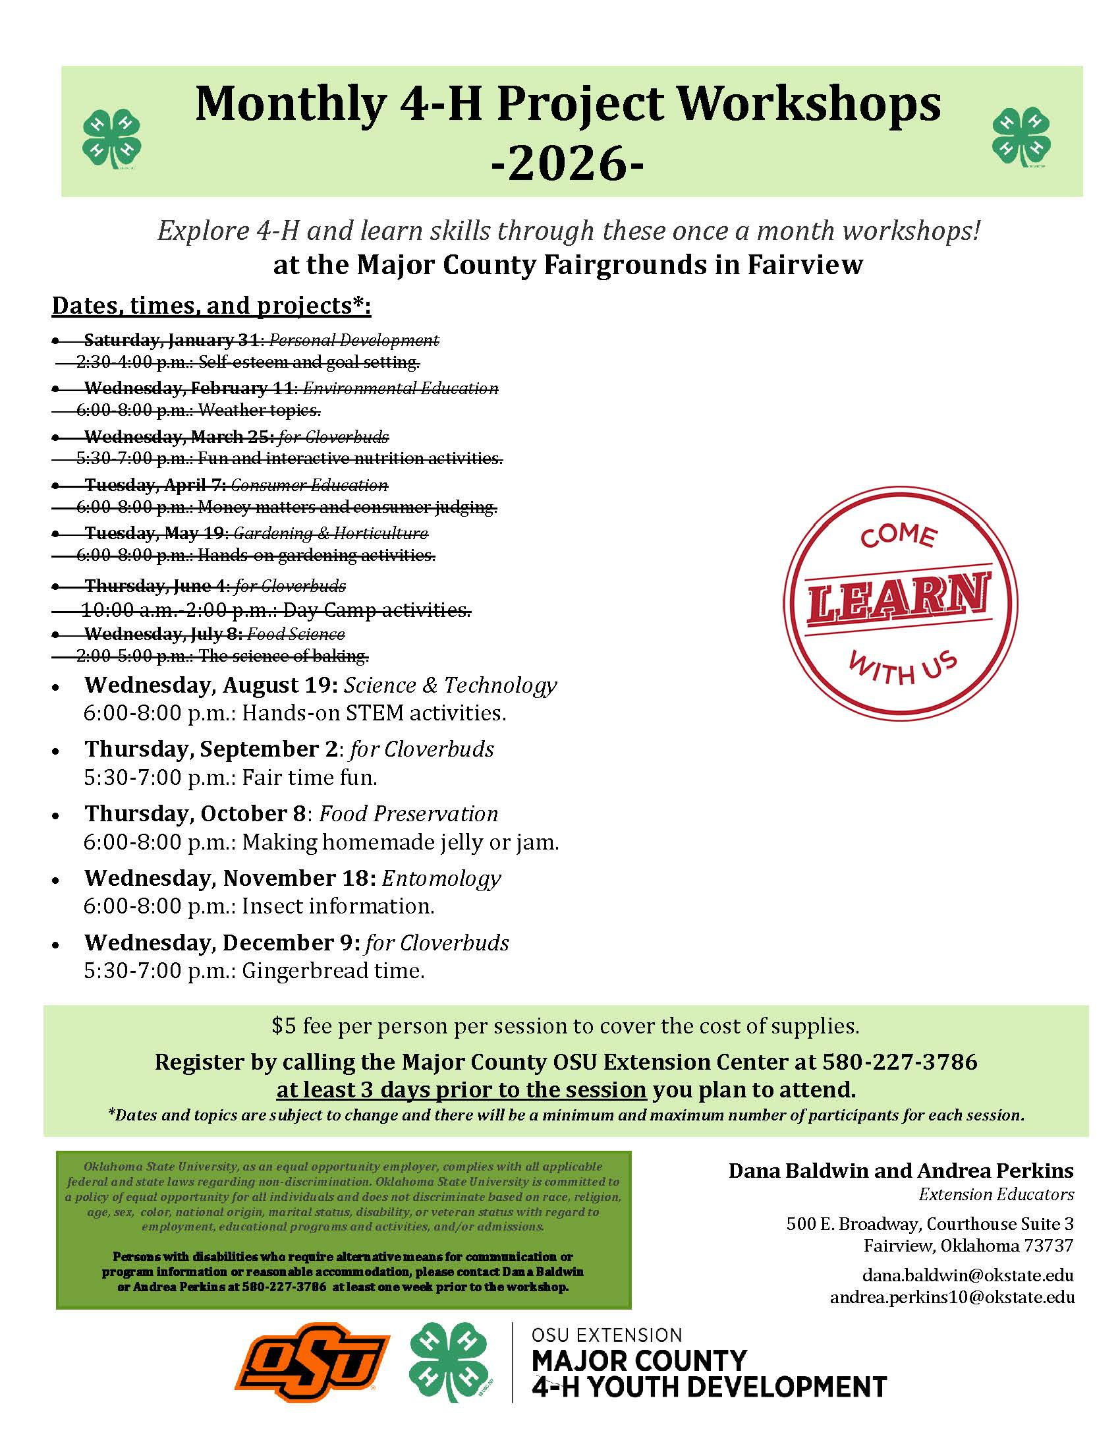


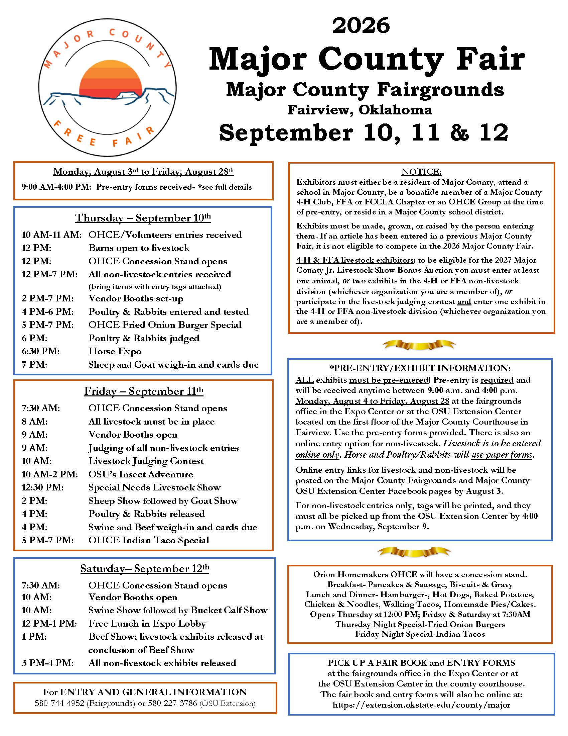



“4-H Clover Connection” is published on a regular basis at the Major County OSU Cooperative Extension Center. This newsletter is just one way of communicating educational information to the citizens of Major County. Major County OSU Cooperative Extension Service educational program and information are provided to you, in part, through the Major County sales tax. Oklahoma State University, U.S. Department of Agriculture, State and Local Governments Cooperating. Oklahoma Cooperative Extension Service: Oklahoma State University, as an equal opportunity employer, complies with all applicable federal and state laws regarding non-discrimination. Oklahoma State University is committed to a policy of equal opportunity for all individuals and does not discriminate based on race, religion, age, sex, color, national origin, marital status, disability, or veteran status with regard to employment, educational programs and activities, and/or admissions. For more information, visit https:///eeo.okstate.edu Issued in furtherance of Cooperative Extension work, acts of May 8 and June 30, 1914, in cooperation with the U.S. Department of Agriculture, Director of Okla- homa Cooperative Extension Service, Oklahoma State University, Stillwater, Oklahoma. This publication is printed and issued by Oklahoma State University as authorized by the Vice President for Agricultural Programs and has been prepared and distributed at a cost of $25.50 .
Editors:

Dana Baldwin Andrea Perkins
Extension Educator Extension Educator
Family & Consumer Sciences/4-H Youth Development Agriculture/4-H Youth Development
and County Extension Director e-mail: andrea.perkins10@okstate.edu
e-mail: dana.baldwin@okstate.edu

Major County OSU Extension Center
500 E. Broadway, Courthouse Suite 3
Fairview, Oklahoma 73737
Phone: (580)227-3786



Major County OSU Extension Office
500 E Broadway, Courthouse Suite 3
Fairview, Oklahoma 73737

